Describe why structured data is a better candidate for a relational DB?

Describe where the different approaches (top-down, bottom-up, centralized, un-centralized) work best?

Describe why there is a need for process such as DBLC The Database Life Cycle?

**You can create the tables for these following questions using tables in Word, or use Excel and copy and paste into Word**

Normalize these table to 1NF (all on one table, just to make it normalized to the 1NF )

|  |  |  |
| --- | --- | --- |
| **student_id** | **student_name** | **subject** |
| 101 | Akon | OS, CN |
| 103 | Ckon | Java |
| 102 | Bkon | C, C++ |

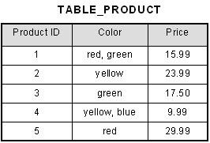

| **Instructor's name** | **Course code** |
| --- | --- |
| Prof. George | (CS101, CS154) |
| Prof. Atkins | (CS152) |

Normalize these tables to the 2NF

|  |  |  |  |
| --- | --- | --- | --- |
| **teacher_id** | **subject** | **teacher_name** | **teacher_age** |
| 111 | Math | Jones | 38 |
| 111 | Physics | Jones | 38 |
| 222 | Biology | Smith | 38 |
| 333 | Physics | Roberts | 40 |
| 333 | Chemistry | Roberts | 40 |

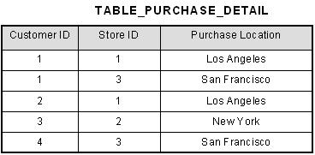

|  |  |  |  |  |
| --- | --- | --- | --- | --- |
| **score_id** | **student_id** | **subject_id** | **marks** | **teacher** |
| 1 | 10 | 1 | 70 | Java Teacher |
| 2 | 10 | 2 | 75 | C++ Teacher |
| 3 | 11 | 1 | 80 | Java Teacher |

|  |  |  |  |  |
| --- | --- | --- | --- | --- |
| **Order Number** | **Customer Number** | **Unit Price** | **Quantity** | **Total price** |
| 1 | 241 | 10 | 2 | 20 |
| 2 | 842 | 9 | 20 | 180 |
| 3 | 919 | 19 | 1 | 19 |
| 4 | 919 | 12 | 10 | 120 |

Normalize these tables to the 3NF

|  |  |  |  |  |  |
| --- | --- | --- | --- | --- | --- |
| Id | First | Last | City | State | zip |
| 12 | Jack | Jones | Lakewood | NJ | 08701 |
| 13 | Jim | Smith | Lakewood | NJ | 08701 |
| 14 | John | Smith | Howell | NJ | 07731 |
| 15 | Jill | Price | Brick | NJ | 08724 |
| 16 | Jerry | Clark | NY | NY | 10036 |
| 17 | Jake | Franks | NY | NY | 10029 |